Curriculum Vitae

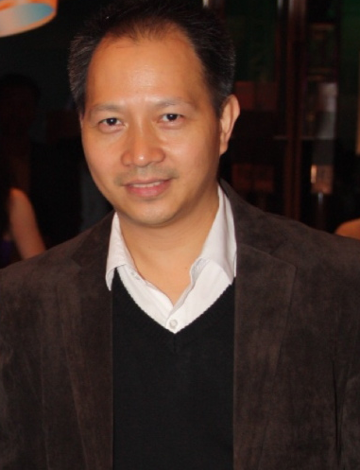
Harith Pichyangkura
8/17 Soi Pradipat 15
Pradipat Rd. Samsane-nai
Phayathai, Bangkok 10400
Email: harithp@gmail.com
Mobile Phone: 0811230004

- Work Summary

- Leading role in all aspects of marketing and marketing communications in Telecommunication company under brand “3BB” for more than 6 years with currently 1.85 M subscriber base monthly billing of 1.5 billion baht network coverage of 77 provinces of Thailand
- Work Experience

- 2015(July)-Present: Vice President at Vice President Office
- 2009-2015 (June) : Vice President Marketing & Customer Relationship, Triple T Broadband PLC (“3BB”)
- 2008-2009 : Vice President Marketing & Sales, Marketing Communications, TT&T ("Maxnet")
- 2007-2008: Internet Service Division Manager, Bangkok, TT&T PLC.
- 2003-2007: Sales Manager, Planning Manager in North and Central region, TT&T PLC
- 2001-2003: Product Management Division Manager, Bangkok, TT&T PLC.
- 1995-2001: Cable Television (TT&T)
- Education

- 1994-1995 MS in Computer Information System (CIS), Assumption University, Thailand
- 1985-1989 BA in Political Science (major) and French (minor), State University of New York at Stony Brook, New York, U.S.A.
- Scholarship

- 2000 scholarship granted by Swedish International Development Agency (SIDA) under Swedish government, Customer Services Management at Telia Academy AB, Kalmar, Sweden (August 8th-September 7th 2000)
- Personal Data

- Age: 49,Male, Married
- Others
-Furnished upon request

Work Summary

Actively heading the Marketing Department includes marketing communications, customer relationship and PR with team of 15 staff for more than 10 years. The customer base is 1.85 M subscriber base with monthly billing of 1.5 billion baht. The network covers all of the 77 provinces of Thailand. Our Company has the total of 6,000 staff nationwide. The work experiences are expanded across sales (mass and corporate), planning, VAS services, product management, marketing and sales operation, outlet management, member of committee and trainer etc.

The telecommunication experience holds about 20 years with a range of product such as telephone (land line), Cable Television, VAS (SMS, Caller ID), Dial Up internet, Fix broadband (Maxnet, 3BB) brand set up from initial stage to its success. Now, 3BB is no. 2 and a good number 1 contender. During the time, I was in charge of Marketing campaigns and Event Promoter (Mass, Selective Market) BKK, Nationwide, Co-Marketing, Co-Campaign, Channel Distribution: set up strategy manage nationwide (400+shops), design & standardized shop, Research and Intelligence, Customer Insights(online questionnaire), Industry Analysis. Marketing Communications, my responsibility was to manage all integrated media and budget planning, set up strategy for on and offline. I set up our own creative team, own media to reduce cost and increase performance. Moreover, I have a very good relationship with many strategic partners for instance telecom and IT industry; AIS, DTAC, CAT, INTEL, contents online & mobile game gaming gears industry; Garena, Asiasoft, bank industry; Bangkok Bank, Siam Commercial Bank, Kasikorn Bank and retails industry; Central Pattana (CPN), Tesco Lotus, Big C, Family Mart etc. Marketing budget size is around 800-1,200 Mbt per annum.

Special Project, I build from the concept (“Broadband for gamer”) to implementation for game online segment (all dimensions: Provider, User, Game Café and Media) with continuing success for the past 3 years. This project helps gaining and at the same time retains existing customers.

Other scope of work involves Customer Relationship Management (CRM) campaign and activity
,Public Relation (internal & external) news release, press conference and CSR campaign and activity such as Internet for elementary school project with more than 500 elementary schools, technician school project ….etc. For example; CRM, I personally originated from concept to implementation with more than 20 partners and yearly campaign for the past 2 years. CSR, I was in charge and of the project with yearly of 80-100 school visits.

Other company project: I was in charge of IF team (Infrastructure Funding) all media from design to implement work closely with FA and consultant and related parties, Roadshows, Press Conference, 1st day Trade.

Currently, I am working with Vice President Office oversees marketing, new business 4G, other marketing and partner projects. For new business (4G), I am in a marketing working group in charge of package and promotion, outlet & distribution channel, VAS on mobile, handset selection, logistic, and other OTT, IoT and LTE-M.

